|  |
| --- |
| **LAPORAN PRAKTIKUM PENGENALAN BASIS DATA**  **ER-MODELLING** |
|  |
| **Agus Pranata Marpaung**  **13323033**  **DIII TEKNOLOGI KOMPUTER** |
| **INSTITUT TEKNOLOGI DEL**  **FAKULTAS VOKASI** |

**Judul Praktikum**

|  |  |  |
| --- | --- | --- |
| **Minggu/Sesi** | : | II/2 |
| **Kode Mata Kuliah** | : | 1131205 |
| **Nama Mata Kuliah** | : | PENGENALAN BASIS DATA |
| **Setoran** | : | *Softcopy* |
| **Batas Waktu Setoran** | : | *1 Februari 2024 jam 21:00* |
| **Tujuan** | : | 1. *Mahasiswa mampu membuat model ER dari studi kasus* |

**Petunjuk**

1. Membaca soal-soal yang diberikan secara cermat/teliti.
2. Mencari sumber-sumber lain seperti buku, artikel, bahkan video untuk memperkaya wawasan dan meningkatkan pemahaman anda.
3. Gunakan tools seperti StarUML atau Draw.io untuk menggambar ER-Modelling
4. Jika anda merasa ada hal yang belum dipahami, silakan untuk berkonsultasi pada TA.

**CASE STUDY 1 (15 POINT)**

A computer institute registers various students for different courses. The courses are taught by faculty members at the institute. A student may register for one or more courses and a course may have one or more students. A course is taught by one faculty. However, a faculty may conduct multiple courses. The information to be stored about students includes the registration number, name, address, phone, date-of-birth and date-of-joining. The course details to be stored include course_ID, course_name, duration and fees. Faculty details to be stored are faculty_id, name, address and phone number.

**Jawab:**

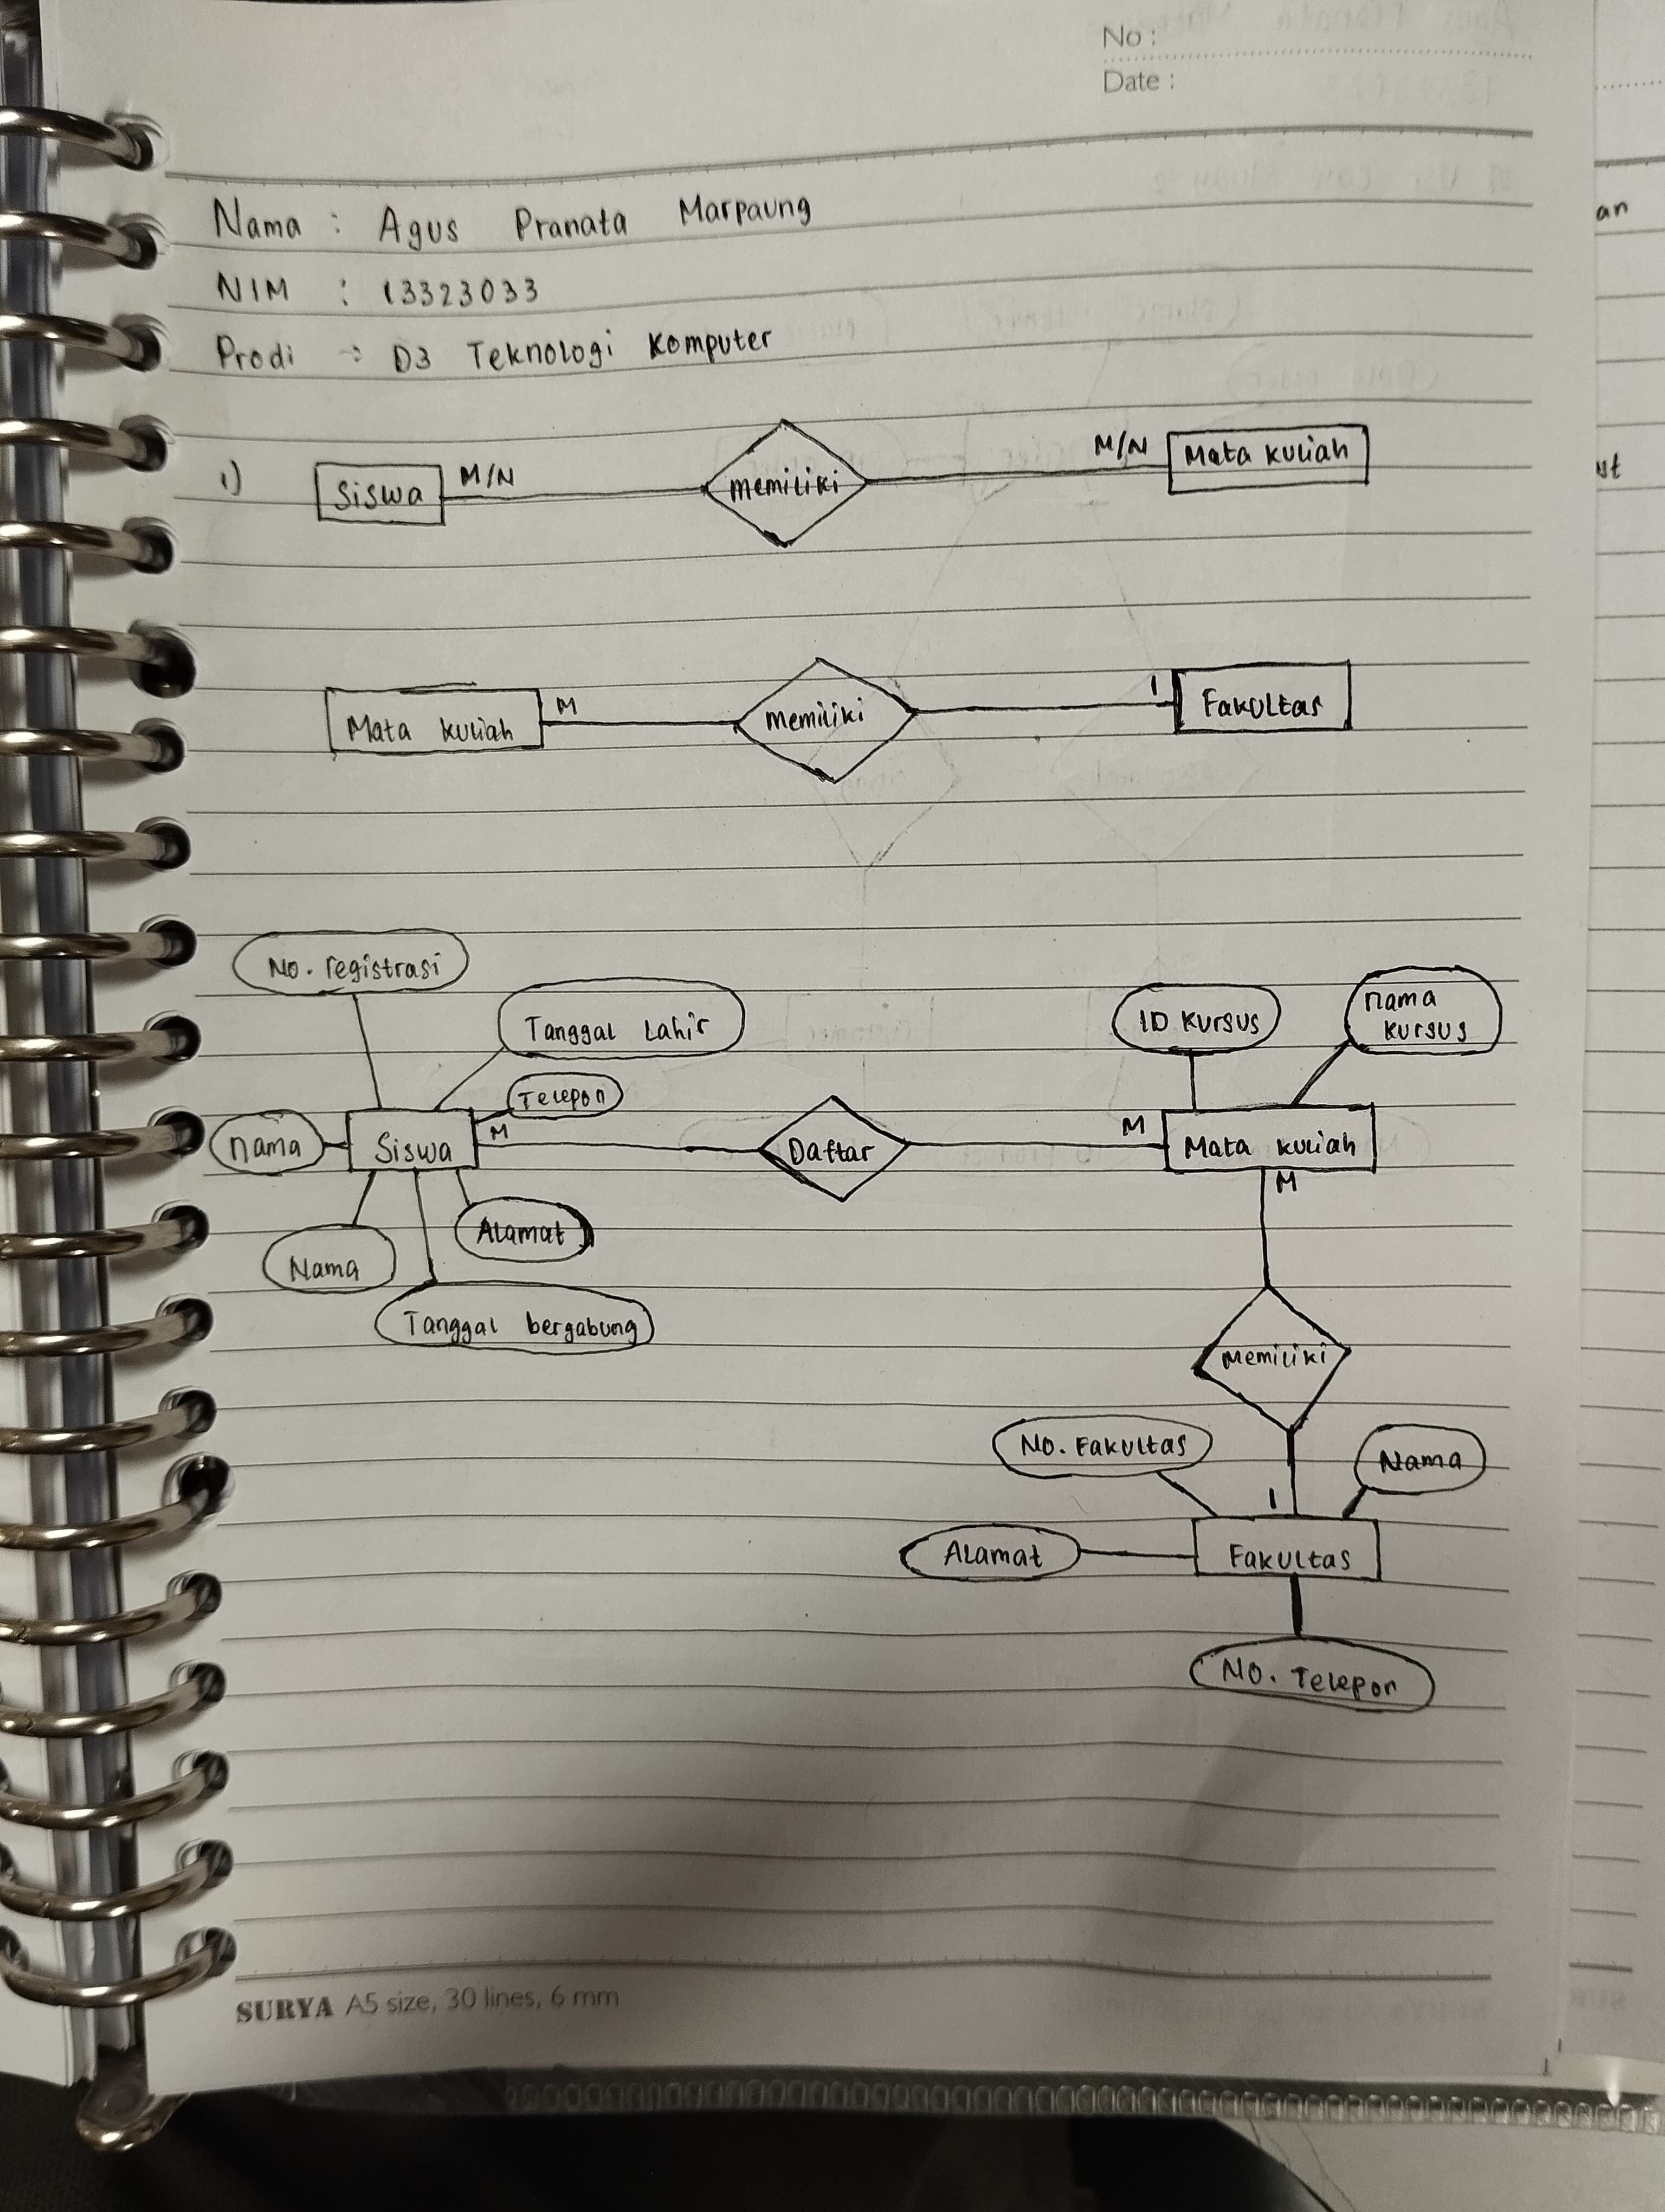

**CASE STUDY 2 (25 POINT)**

**Create an ER Model of the following description (using Diamond Notation/Chen):**

A customer can place an order for one or more products. Customers that have not placed any orders can be included in the customer database for purposes of marketing research. Products that have not been ordered can be part of the product database. An order has to be associated with at least one product but can be associated with many products.

**Jawab:**

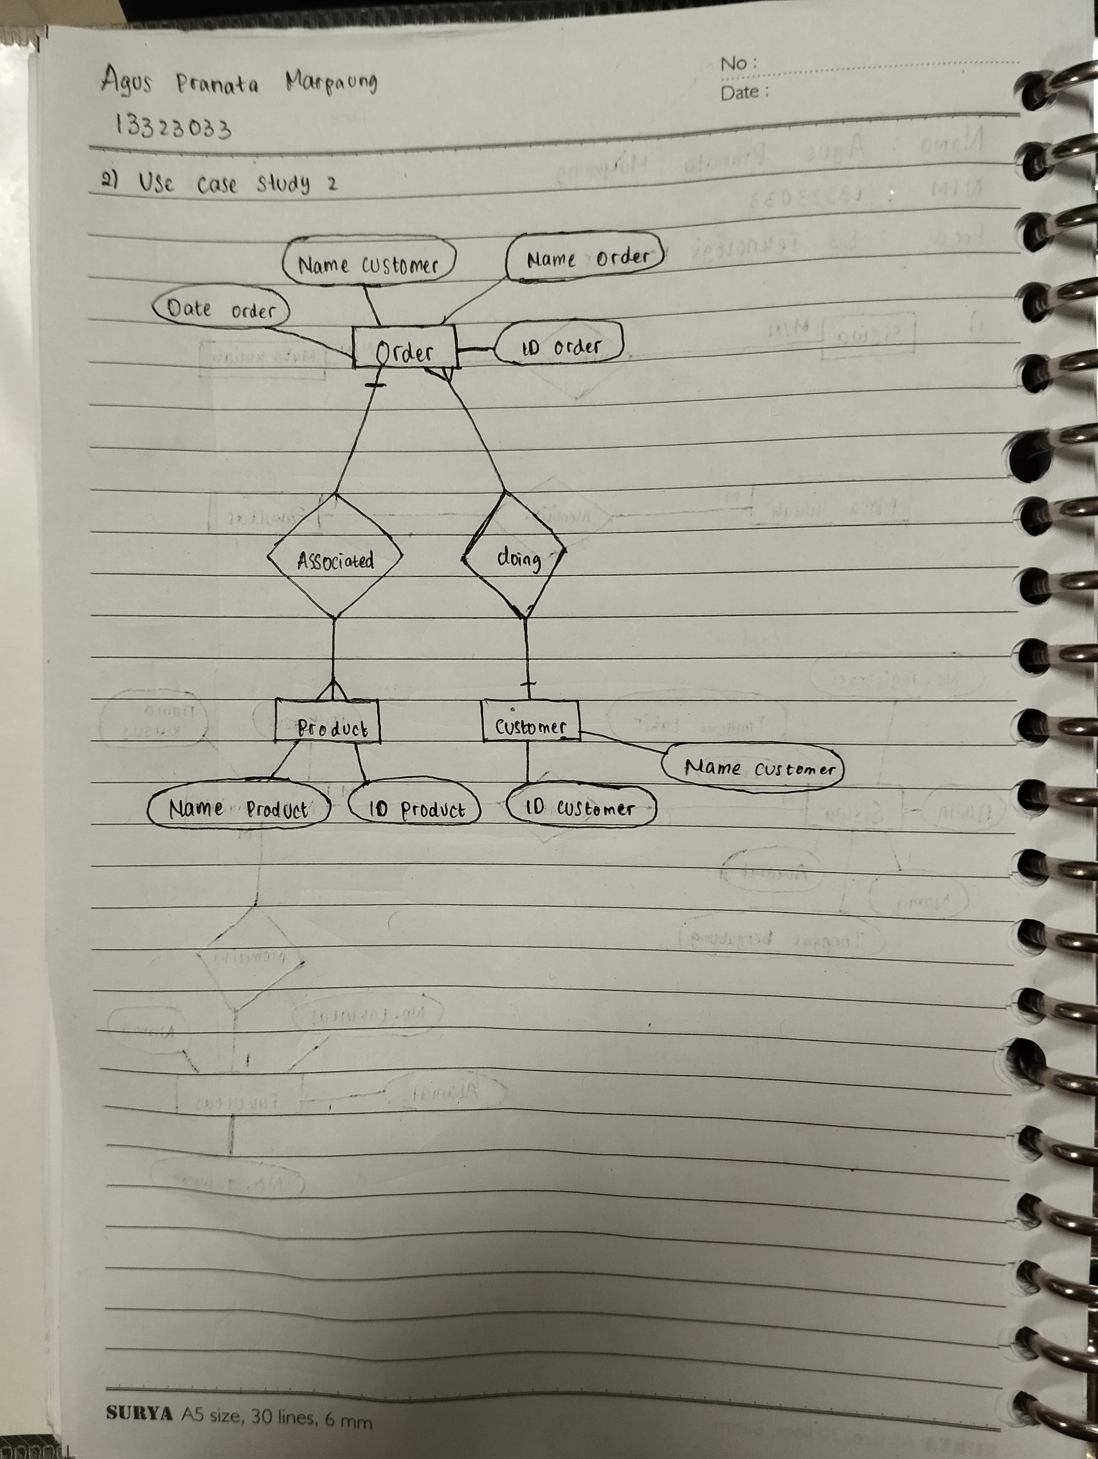

**CASE STUDY 3 (25 POINT)**

**Create an ER Model for each of the following description (using Crow’s foot notation/Martin):**

1. Each company operates four departments and each department belongs to one company. (5 point)
2. Each department in part (a) employs one or more employees, and each employee works for one department. (5 point).
3. Each of the employee in part (b) may or may not have one or more dependents and each dependent belongs to one employee. (5 point)
4. Each employee in part (c) may or may not have an employment history. (5 point)
5. Represent all the ER model described in (a), (b), (c), and (d) as a single ER Model. (5 point)

**Jawab:**

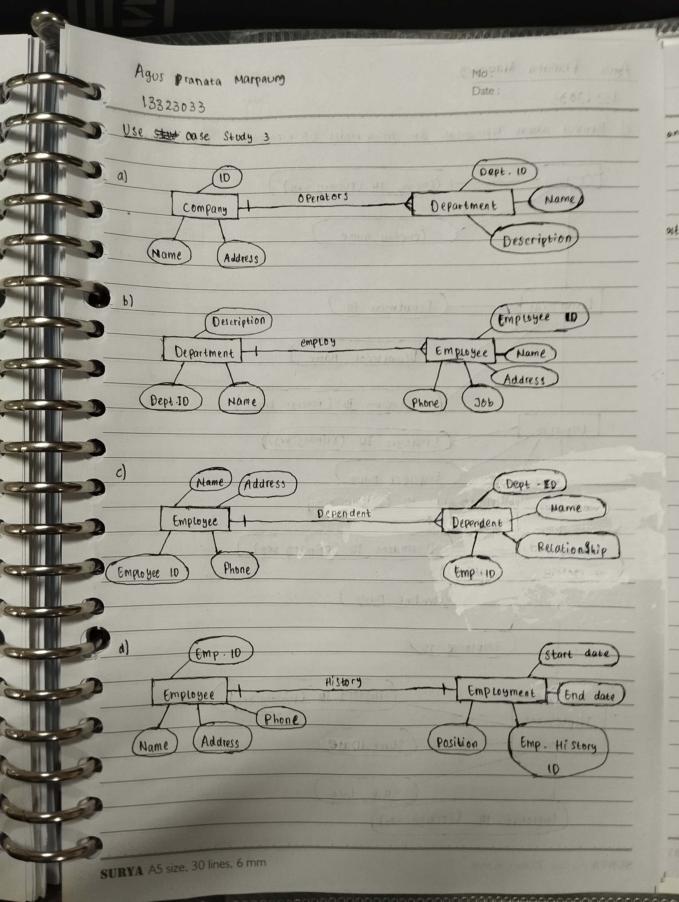

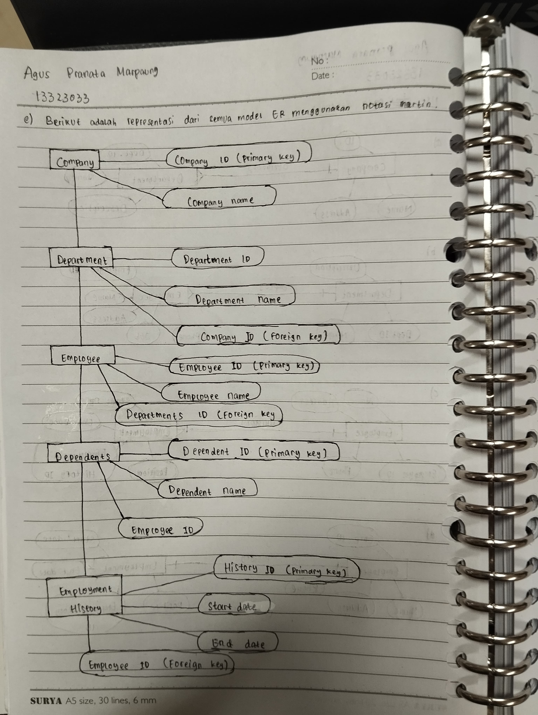

**CASE STUDY 4 (35 POINT)**

Rooms are situated on floors and are identified by a floor number and a room number (ie 1.1, 1.2, → the first and the second room in floor 1). For each floor, we want to register at least one room and register the number of emergency exits as well. For each room the number of seats in the room – if known – is registered and all facilities – if present – that the room is equipped with. Facilities are identified by a facility code and for each facility we store the full facility name as well. At any time it must be possible to ask for facilities that are available – even if not in any room – and it must be possible to register new facilities as well.

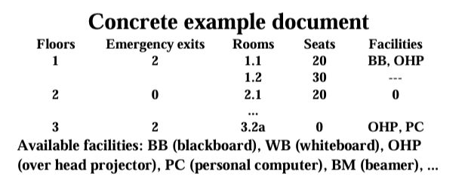

**Jawab:**

